  - tic-tac-toe

name-gauri chaudhary

registration number- 25bai10976

date-november 24 , 2025

course-python essentials

slot-A14-D11-D12

Introduction
This report documents the design and implementation of a two-mode Tic-Tac-Toe game developed in Python. The core objective was to create a functional, modular, command-line application that allows for both two-player and player-versus-random-AI gameplay. The project demonstrates the use of key programming concepts, including list manipulation for board state, robust input validation using try-except logic, and function-based modular design. The inclusion of the computer_move function utilizes the random library, adding complexity beyond a simple two-human-player implementation.
Problem Statement
The challenge is to model the Tic-Tac-Toe game rules while accommodating two distinct game modes. The system must:
- Manage the 3 CROSS 3 grid state efficiently using a 2D data structure.
- Accurately map the user's single-digit input (1-9) to the correct row and column indices.
- Handle game logic (win and draw detection) for both human and AI moves.
- Provide a simple AI capable of selecting valid, random moves.
Functional Requirements
ID | Requirement | Description (As implemented in code)
FR1 | Mode Selection | The user must be able to choose between "Player vs Player" (1) and "Player vs Computer" (2).
FR2 | Board Representation | The board must be initialized as a 3 CROSS 3 list of lists containing empty space markers (" ").
FR3 | Input Mapping | The function get_player_move must correctly convert user input (1-9) into (row, col) indices using division (//) and modulo (%).
FR4 | Input Validation | The get_player_move function must reject non-numeric input, numbers outside 1-9, and moves on occupied spaces.
FR5 | AI Move Generation | The computer_move function must select a valid, unoccupied position randomly using the random.choice method.
FR6 | Win/Draw Detection | The system must check and announce a win (check_winner) or a draw (board_full) after every turn.

Non-Functional Requirements
ID | Requirement | Description
NFR1 | Reliability | The code must not crash due to typical user errors (handled by the try-except in get_player_move).
NFR2 | Modularity | Logic must be separated into functions (print_board, check_winner, computer_move, etc.) to enhance code clarity.
NFR3 | Readability | The check_winner function must clearly define all 8 win vectors for easy verification of the game logic.
NFR4 | Efficiency (AI) | The AI move calculation (computer_move) should be fast, utilizing list comprehension to quickly find all empty slots.

System Architecture
The system follows a Procedural, Monolithic Architecture centered around the tic_tac_toe() controller function.
The system is logically divided into three layers:
- Presentation/Display Layer: The print_board(board) function.
- Input/Decision Layer: get_player_move(board) (Human input) and computer_move(board) (AI decision).
- Core Logic Layer: check_winner(board, player) and board_full(board).
The tic_tac_toe() function manages the global game state (board, current player, mode) and orchestrates the calls between these layers within the main while True loop.
Design Diagrams
Use Case Diagram
Workflow Diagram
Sequence Diagram
This details the flow for a Player vs. Computer turn:
Component | tic_tac_toe() | get_player_move() | computer_move() | check_winner()
Start Turn | → | Call Input/Move
Player X Turn | → | r, c = get_player_mov e()
 | ← | Returns valid r, c
Computer O Turn | → |  | r, c = computer_move()
 |  |  | ← Returns random valid r, c
Check & Switch | → | Update board
 | → | Check Win/Draw |  | Call check_winner()
 | ← | Switch Player

Class/Component Diagram
Since the code is procedural, this highlights the data structures and functional components.
- Data Structure: Board (List[List[str]] - The 3 CROSS 3grid)
- Components (Functions):
  - Controller: tic_tac_toe()
  - Display: print_board()
  - Input: get_player_move()
  - AI: computer_move() (Uses random library)
  - Logic: check_winner(), board_full()

ER Diagram (Entity-Relationship)
Not applicable. The project uses in-memory storage (a Python list of lists) and does not persist data to a database.
Design Decisions & Rationale
Decision | Rationale
2D List Board | Using board[r][c] (List of Lists) is natural for a grid. This is standard for array manipulation and is intuitively read by the check_winner function.
Random AI | The random library was chosen for computer_move as the simplest path to implementing a non-human opponent, fulfilling the basic FR5 requirement quickly.
Hardcoded Win Checks | The check_winner function explicitly lists all 8 win scenarios. This decision prioritizes code clarity and certainty over writing a more complex, dynamic loop to check combinations.
Input Mapping Formula | The use of r = (pos - 1) // 3 and c = (pos - 1) % 3 is an elegant, concise way to map 1-9 to 0-2 indices, demonstrating effective use of Python operators.

Implementation Details
The project is implemented in a single file and relies on the standard random module.
- Initialization: The board is created using a nested list comprehension: board = [[" " for _ in range(3)] for _ in range(3)].
- Win Check Logic: The core of check_winner is a list containment check: return [player, player, player] in win. This is a Pythonic way to see if the player's marker appears in any of the predefined win vectors.
- AI Implementation: The computer_move uses list comprehension to generate the list of empty coordinates: empty = [(r, c) for r in range(3) for c in range(3) if board[r][c] == " "]. This is efficient and readable
Screenshots / Results

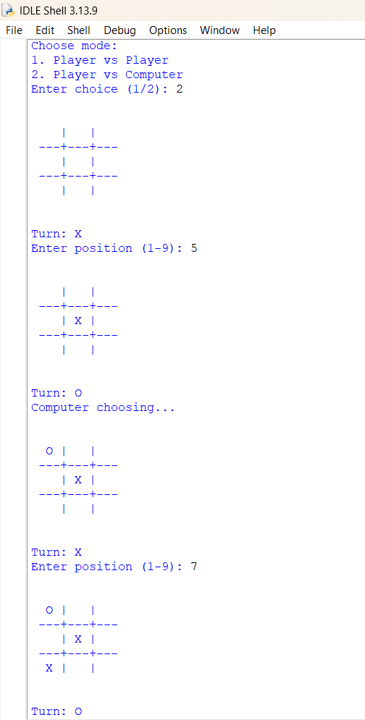
Testing Approach
A Functional (Black Box) Testing strategy was applied to ensure all game logic performs as expected.
Test Case | Procedure | Expected Outcome | Status (Implied)
TC1. Invalid Input | Player enters 'A', then enters 10. | get_player_move prints "Invalid input!" then "Invalid! Enter number between 1-9." | Pass
TC2. Position Taken | Player enters 5, then enters 5 again. | get_player_move prints "Position taken! Try again." | Pass
TC3. Vertical Win | Player 'X' makes 3 moves in column 1 (1, 4, 7). | check_winner returns True, game breaks, and "X wins!" is printed. | Pass
TC4. AI Validity | Run Player vs Computer mode 10 times. | Computer never attempts a move on an occupied square (due to random.choice(empty)). | Pass
TC5. Draw Game | Force a non-winning sequence to fill the board. | board_full returns True, and "It's a draw!" is printed. | Pass

Challenges Faced
Robust Input Handling: The primary challenge was making get_player_move resilient to different error types (non-integers vs. out-of-range vs. occupied space) while keeping the user informed. This required wrapping the critical section in a single while True loop containing the try-except block to force continuous re-prompting until a valid move is received.
Mode Switch Logic: Ensuring the turn flow in the tic_tac_toe() loop was correct: if mode == "1" or (mode == "2" and current == "X"): vs. the else (Computer move). This conditional was critical to ensure the Computer only plays when it is player 'O' in mode 2.
Learnings & Key Takeaways
Data Structure Choice: The project demonstrated the effective use of a list of lists for 2D array management in Python, particularly for index calculation from user input.
Function Isolation: The clarity of the code is a direct result of isolating concerns: the check_winner function is solely dedicated to logic, and print_board is solely dedicated to output formatting.
Simple AI: The implementation of the Random AI provides a foundation for more complex decision-making algorithms (like Minimax) by clearly defining the method to identify available moves (empty list comprehension).

Future Enhancements
Unbeatable AI (Minimax): Replace the random selection in computer_move with the Minimax algorithm to make the computer an optimal, unbeatable opponent.
Board Indexing Hint: Modify print_board to temporarily display the numbers 1-9 in the empty slots to provide a better visual cue to the user, enhancing NFR2 (Usability).
Refactoring Win Check: Refactor the check_winner function to use loops and iterators to dynamically check rows, columns, and diagonals, rather than hardcoding all 8 combinations.

References
Python Documentation (3.x) - https://docs.python.org/3/
Python random module documentation
Vityarthi Python Course

